# Tuning process

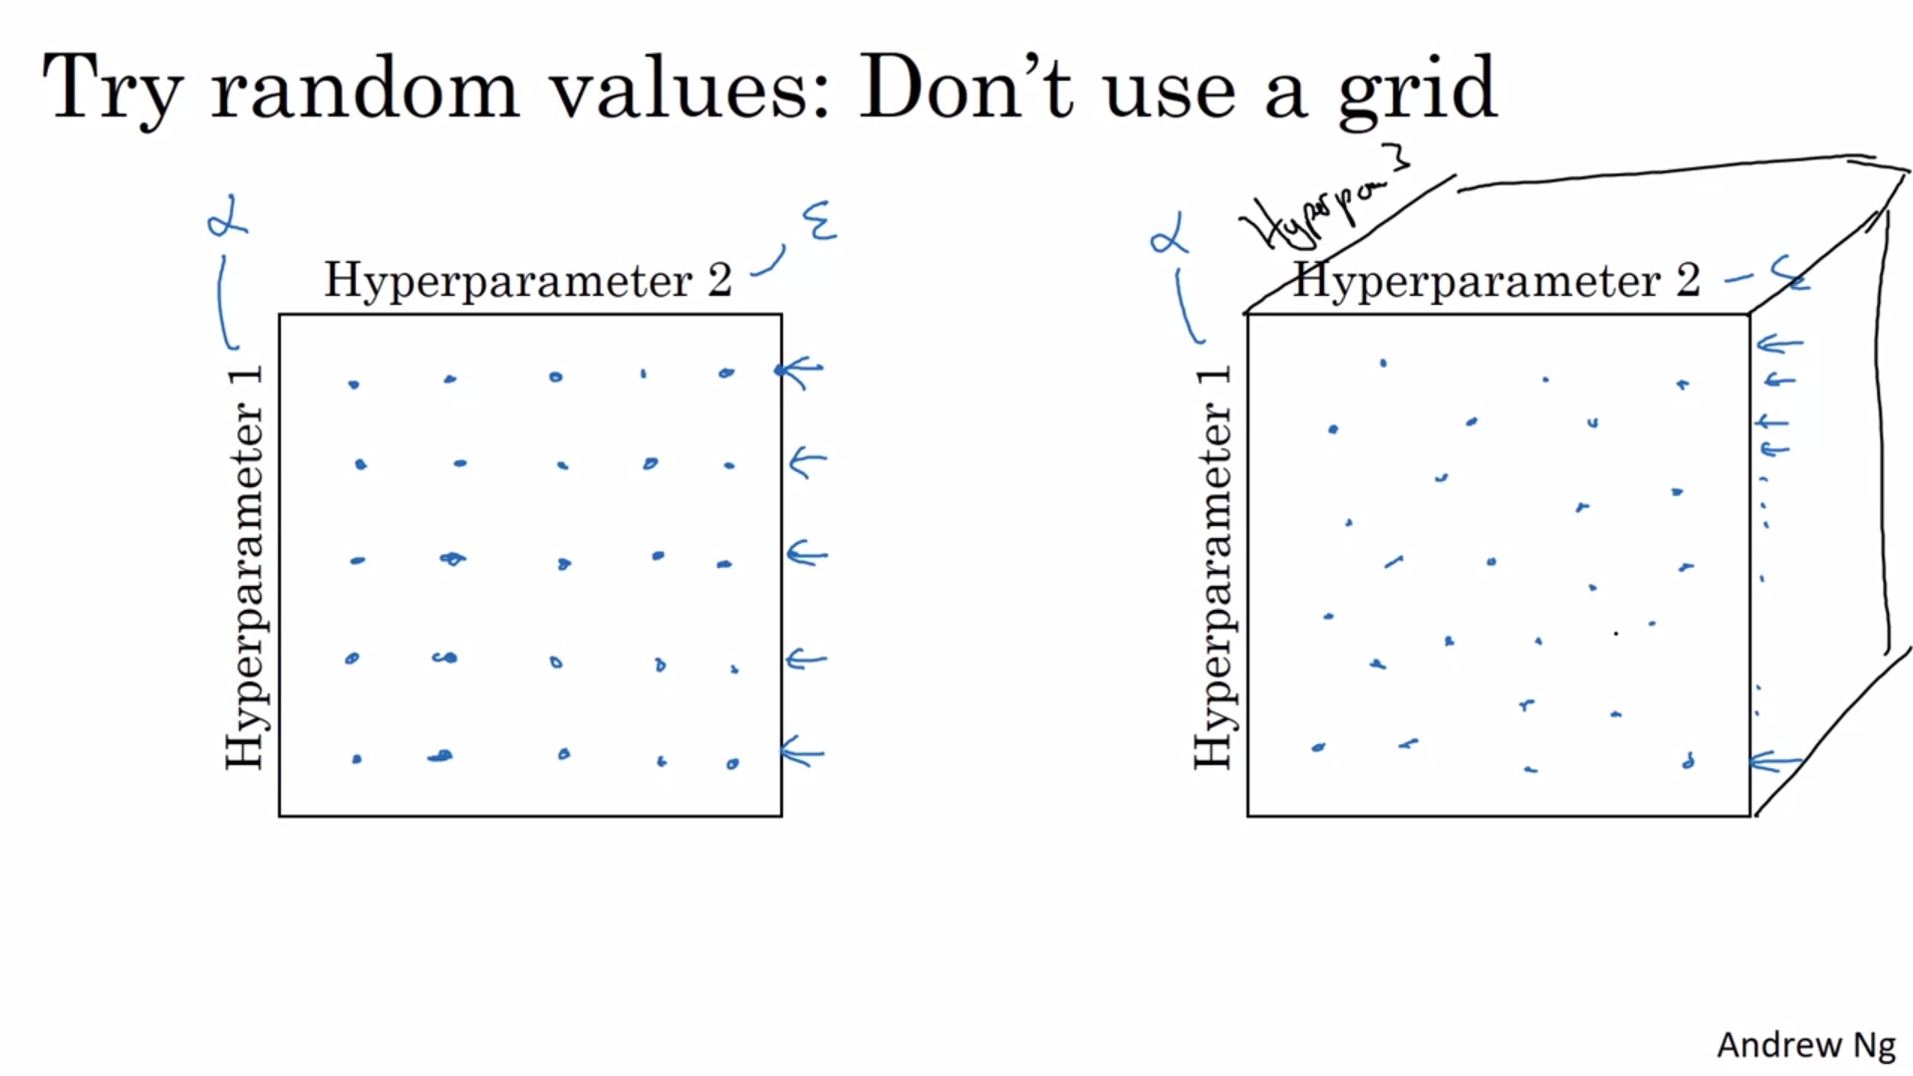

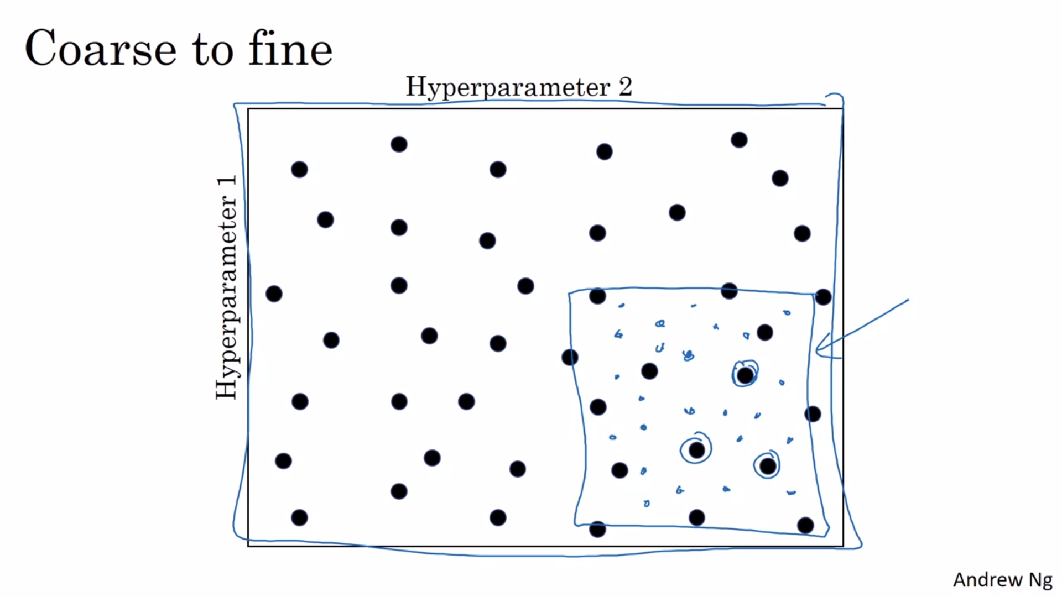

another common practice is to use a coarse to fine sampling scheme.

So let's say in this two-dimensional example that you sample these points,

and maybe you found that this point work the best and

maybe a few other points around it tended to work really well,

then in the course of the final scheme what you might do is zoom in to

a smaller region of the hyperparameters and then sample more density within this space.

Or maybe again at random,

but to then focus more resources on searching within

this blue square if you're suspecting that the best setting,

the hyperparameters, may be in this region

# Using an appropriate scale to pick hyperparameters

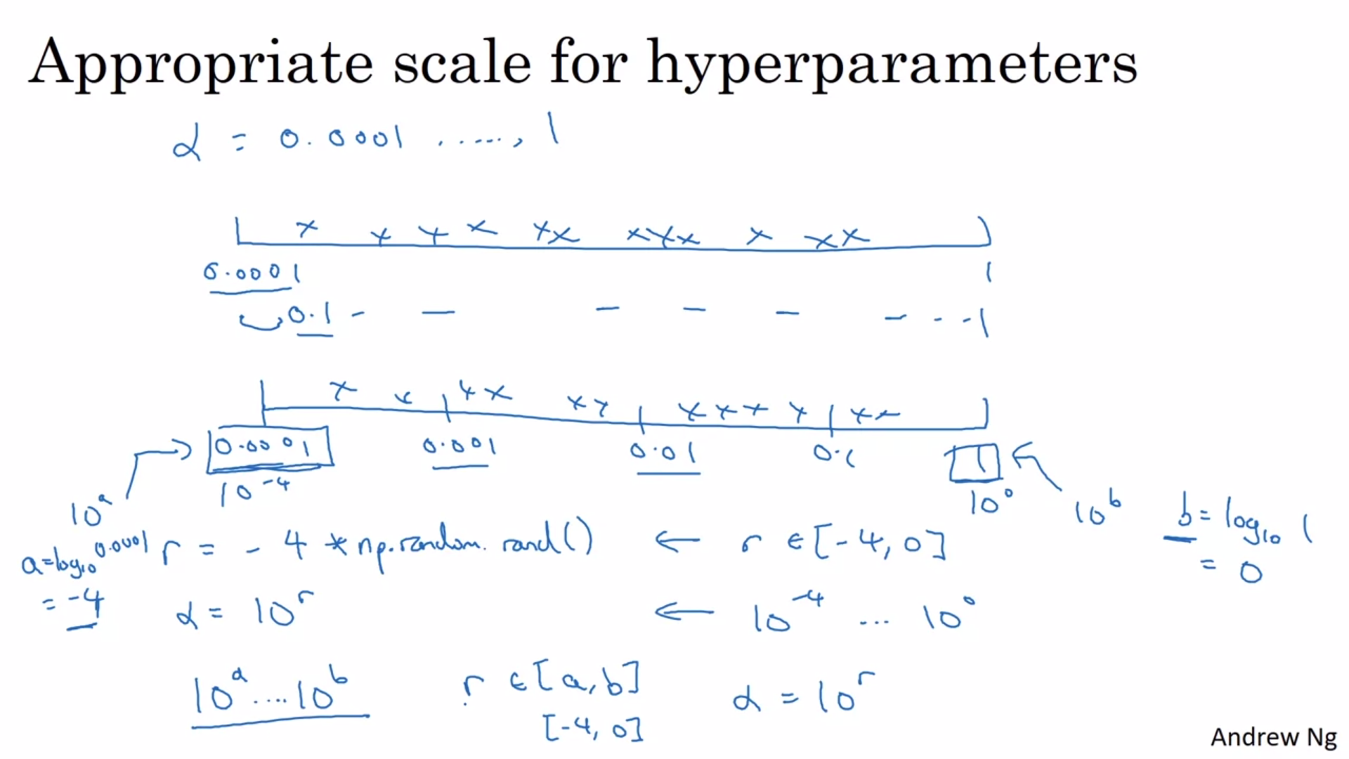

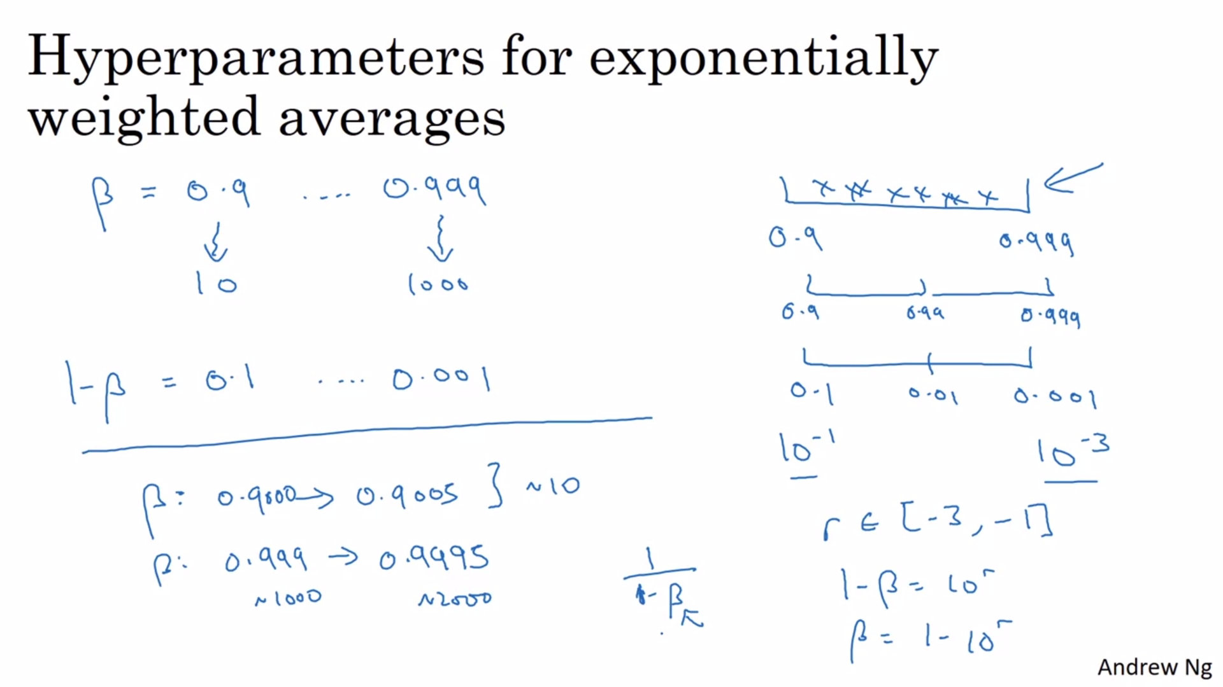

# Hyperparameters tuning in practice: Pandas vs. Caviar

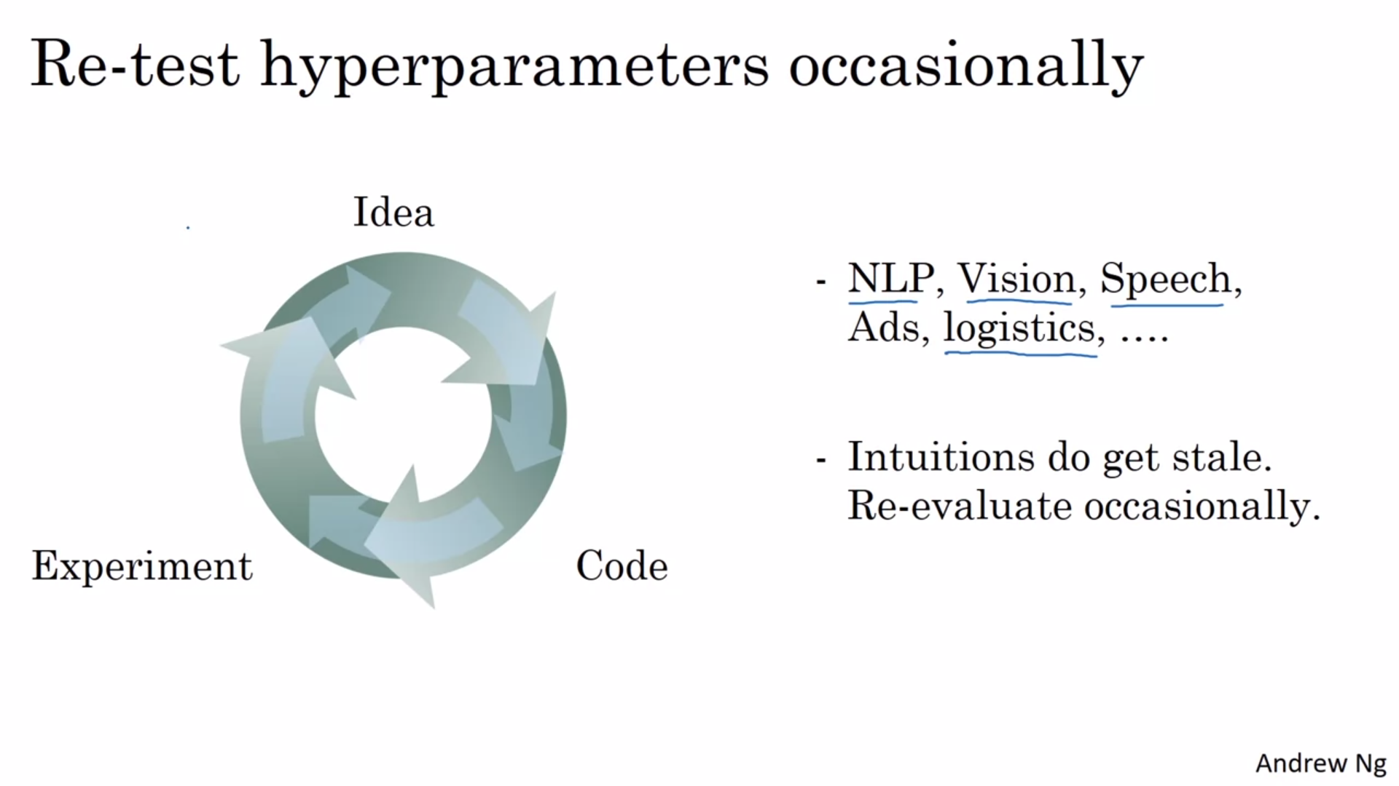

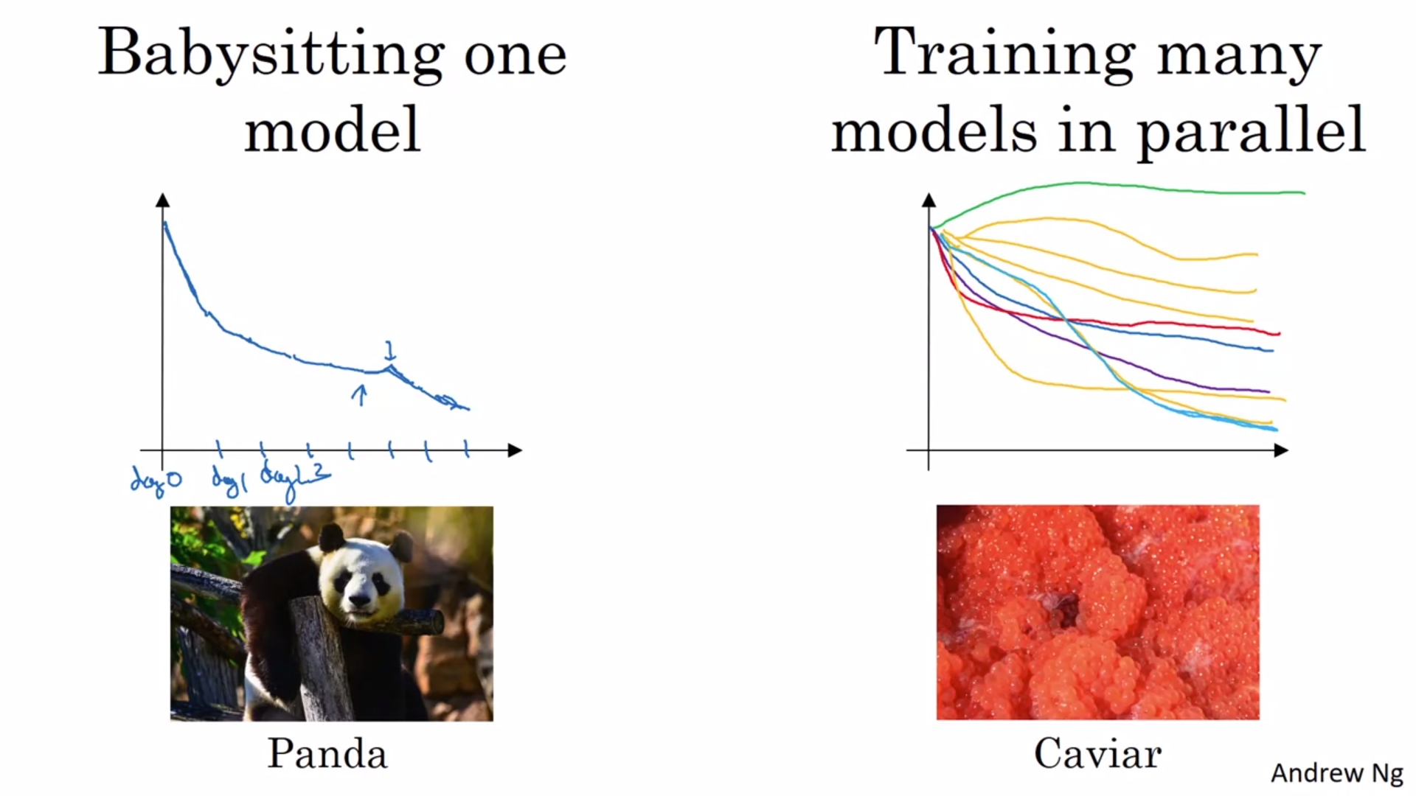

# Normalizing activations in a network

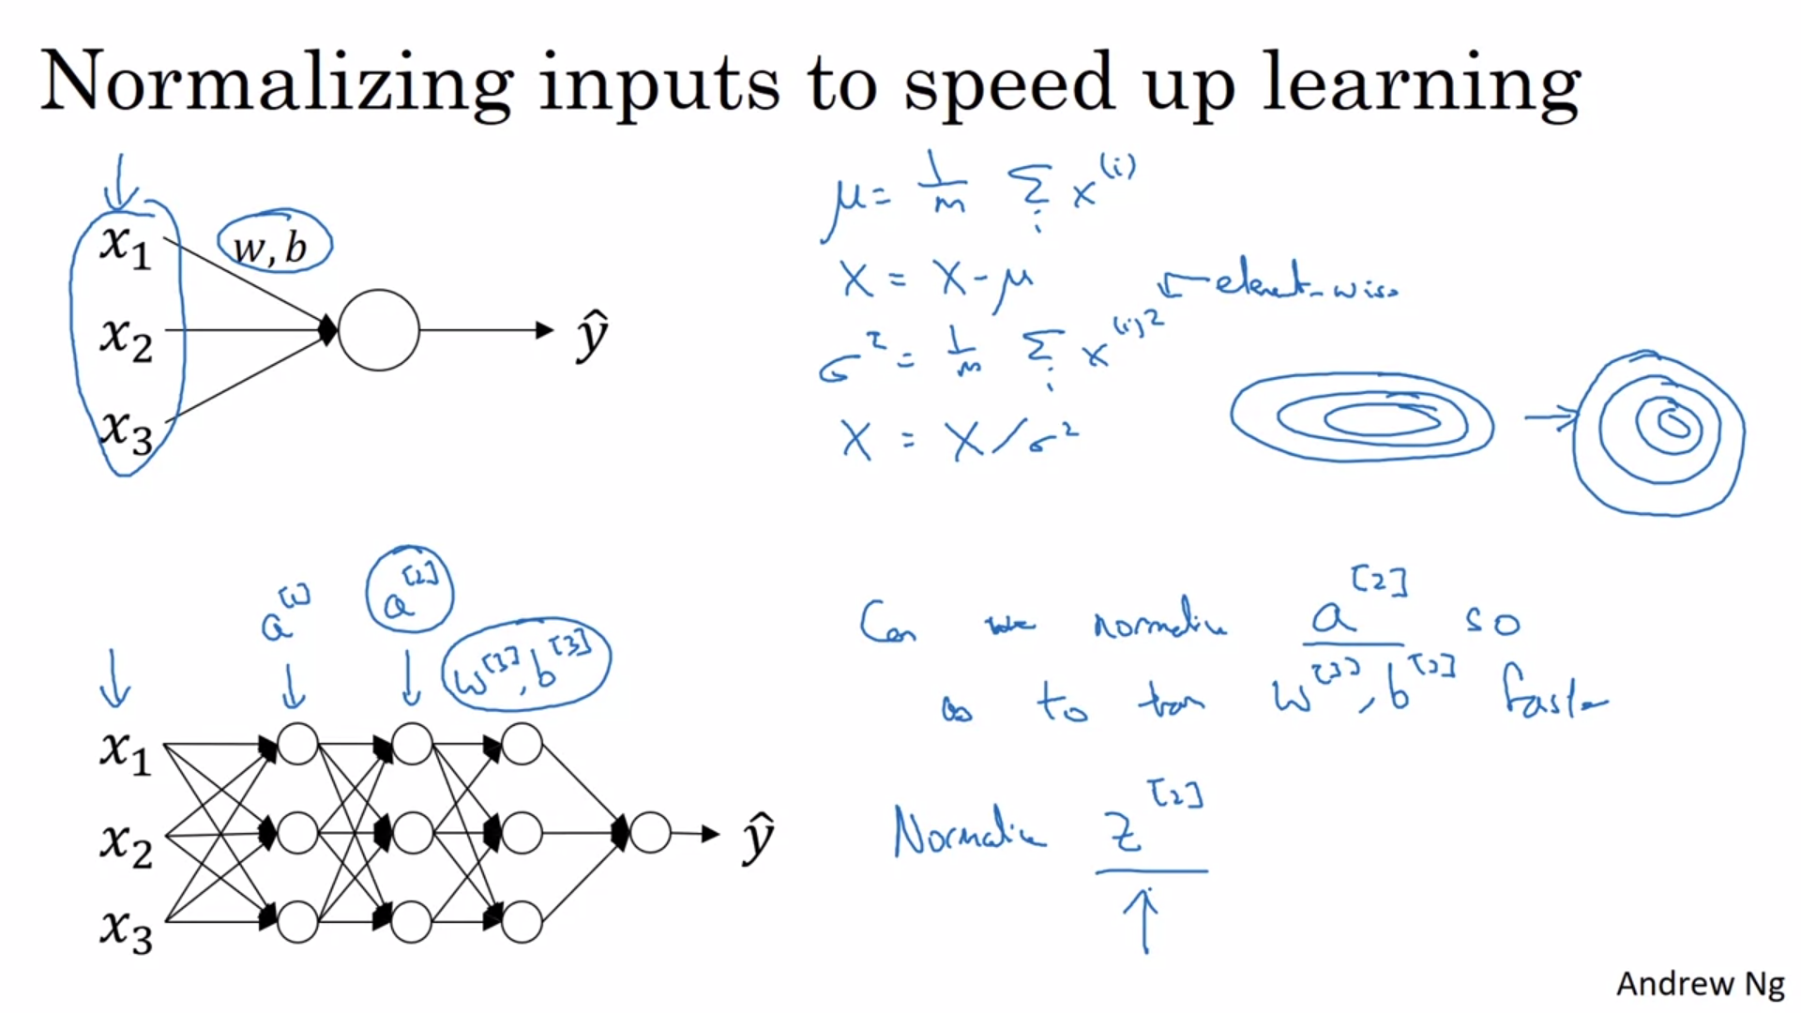

There is debate on normalizing Z2 or A2 but usually, normalization is applied on Z2, hence recommended.

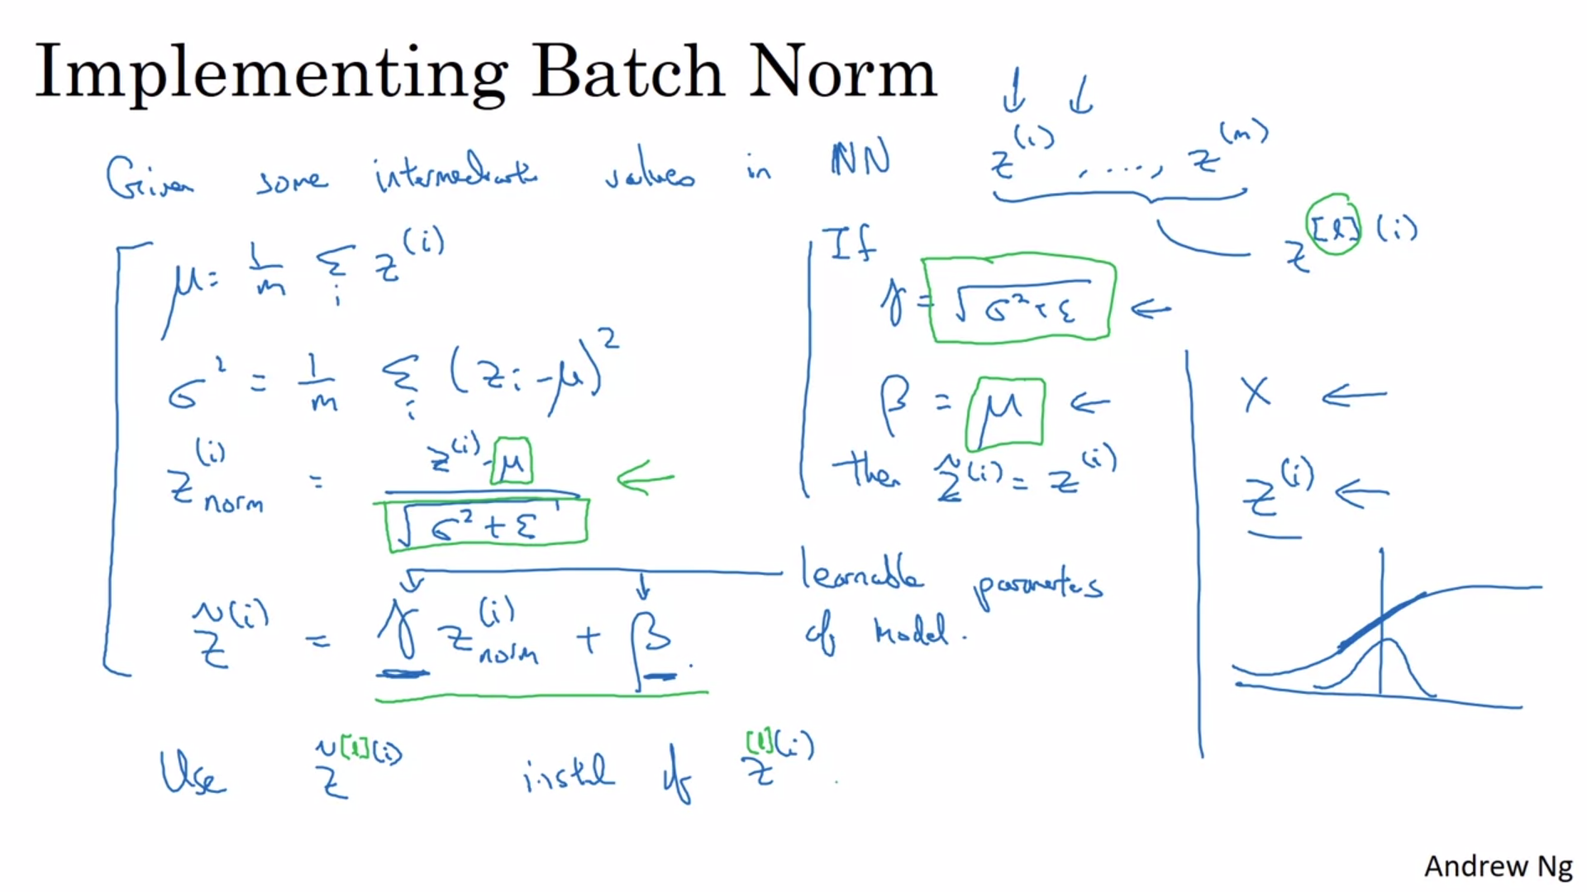

# Fitting Batch Norm into a neural network

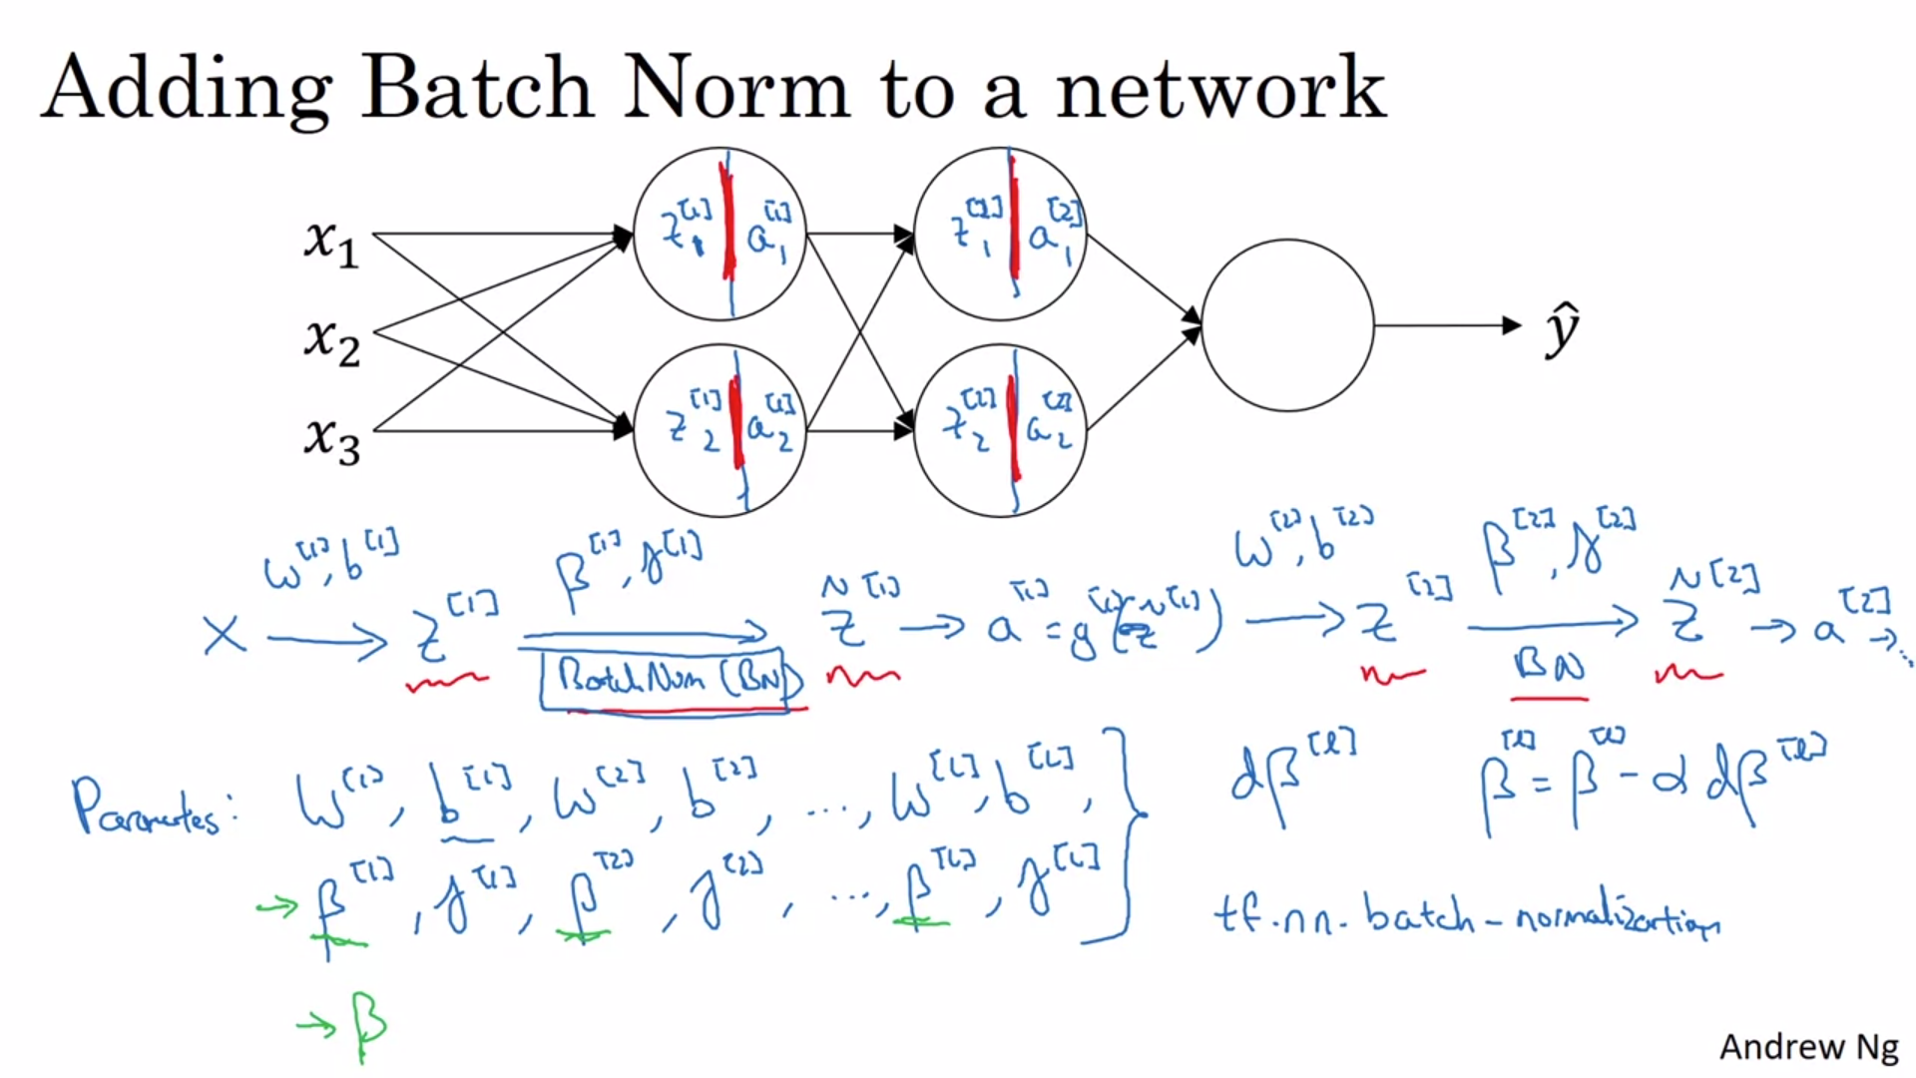

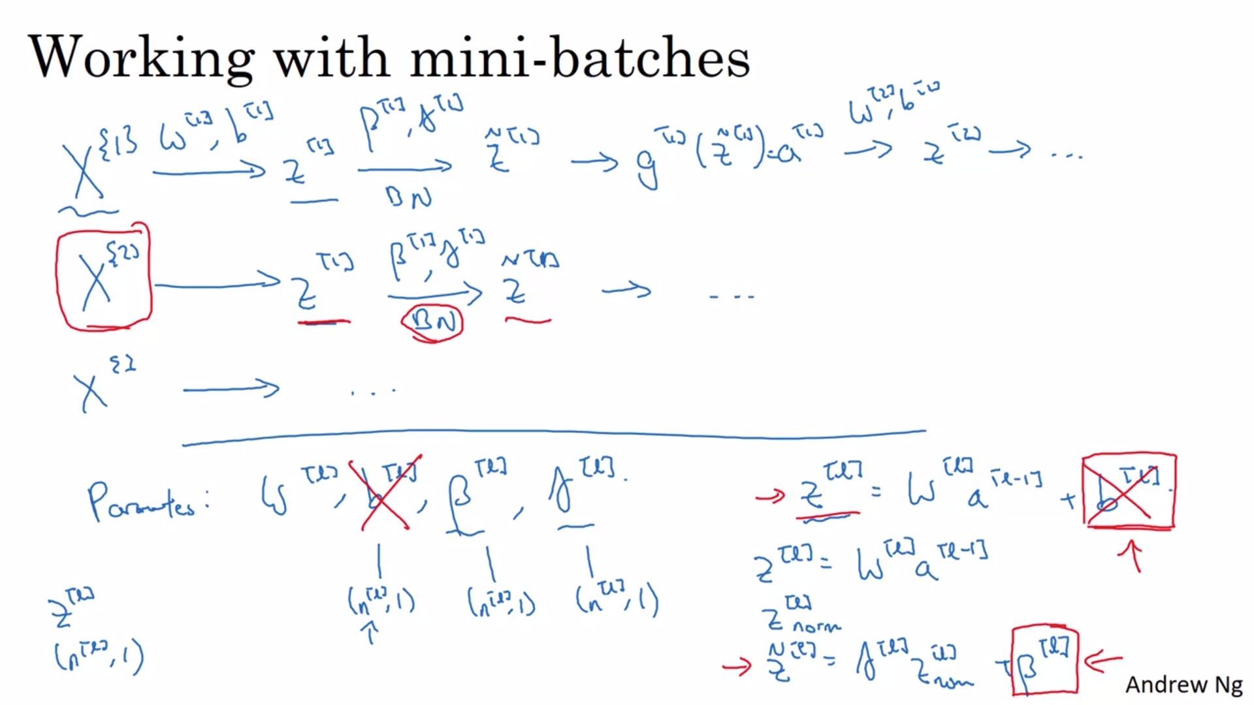

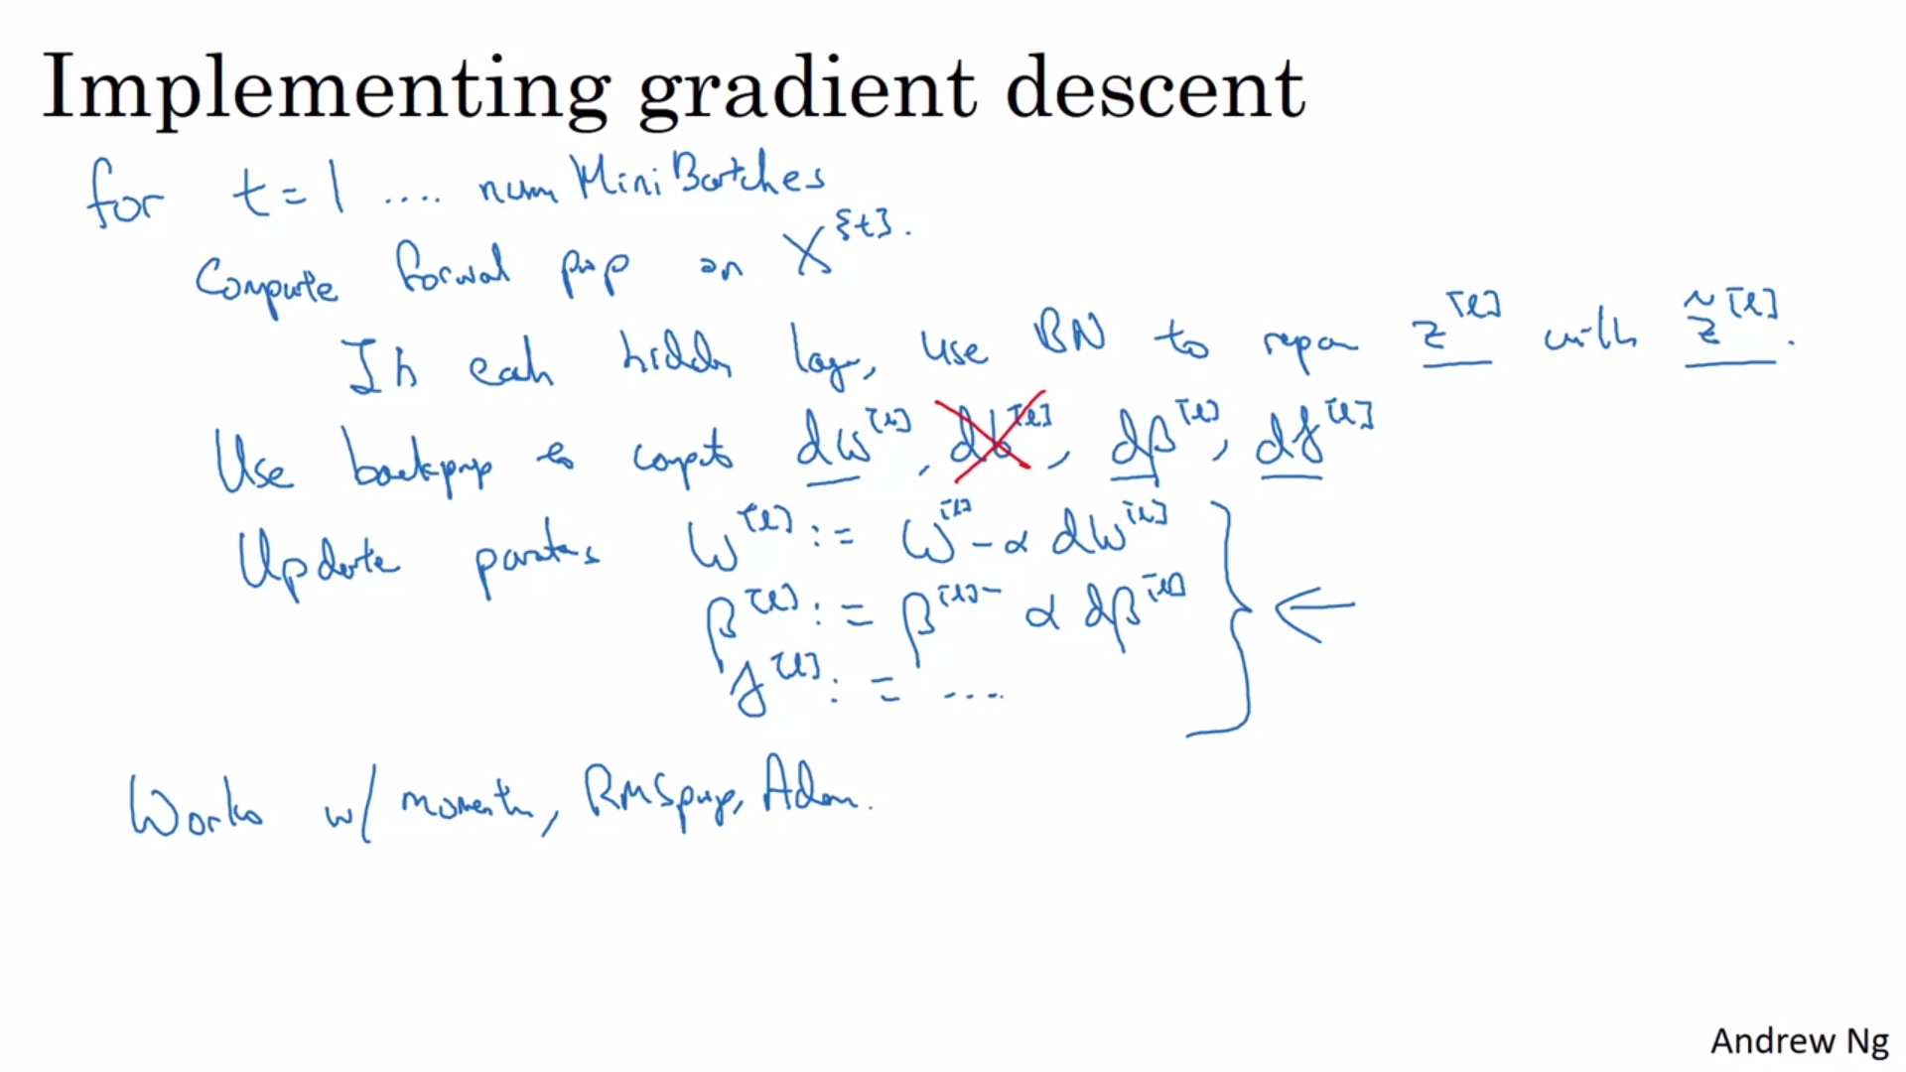

# Why does Batch Norm work?

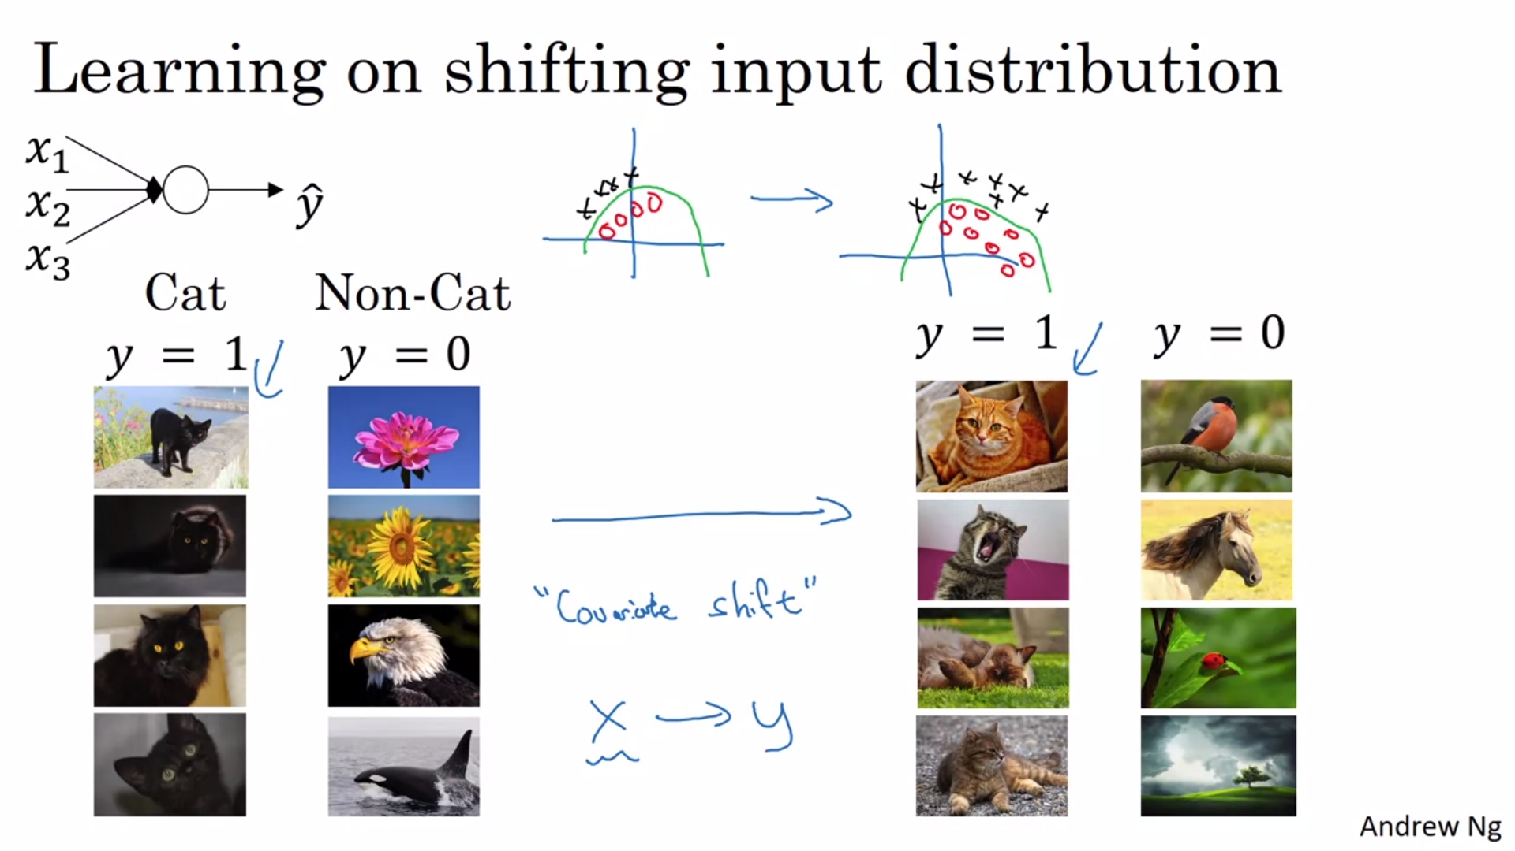

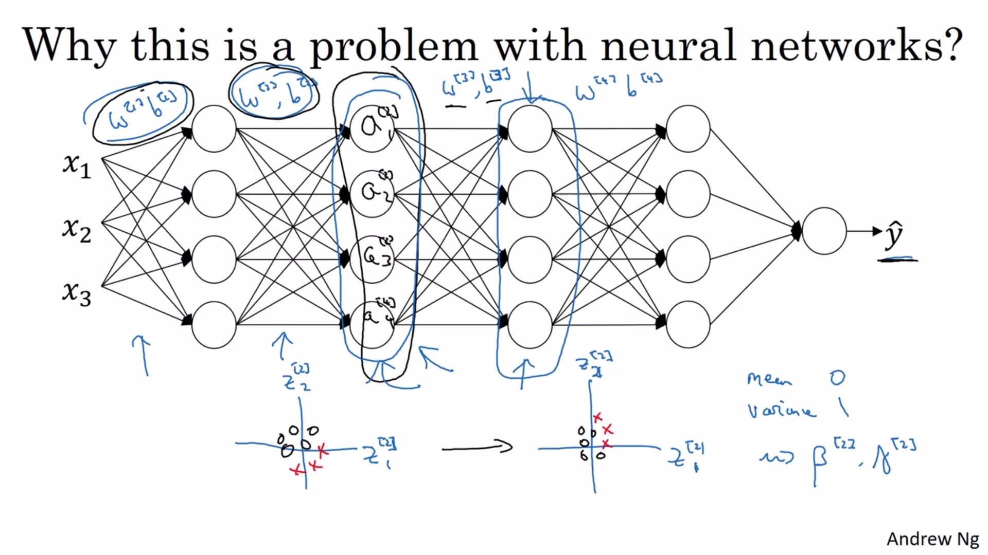

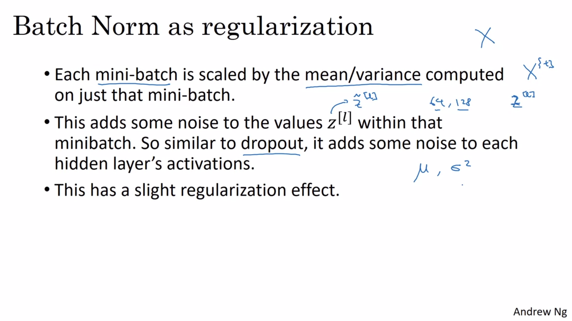

# Batch Norm at test time

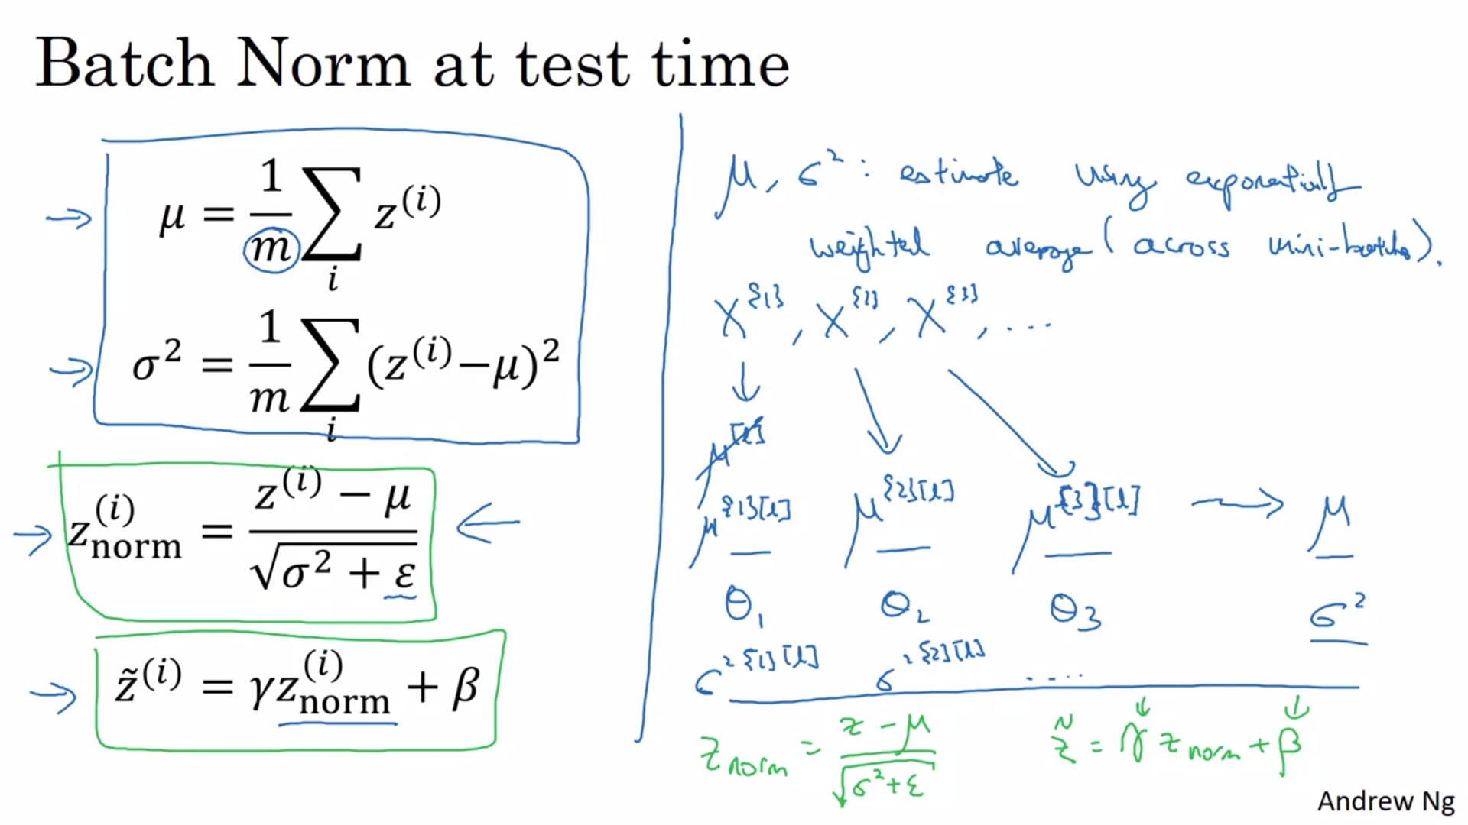

# Softmax Regression for multi class classification

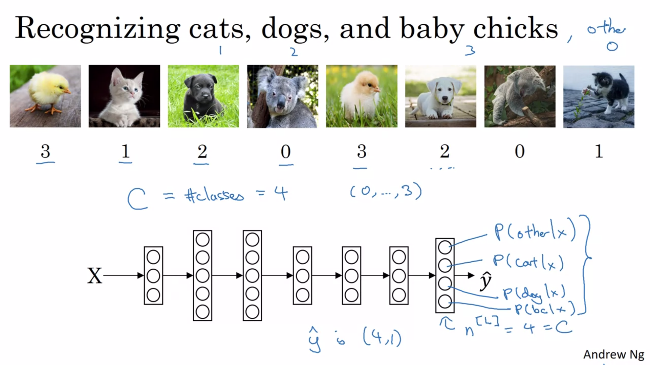

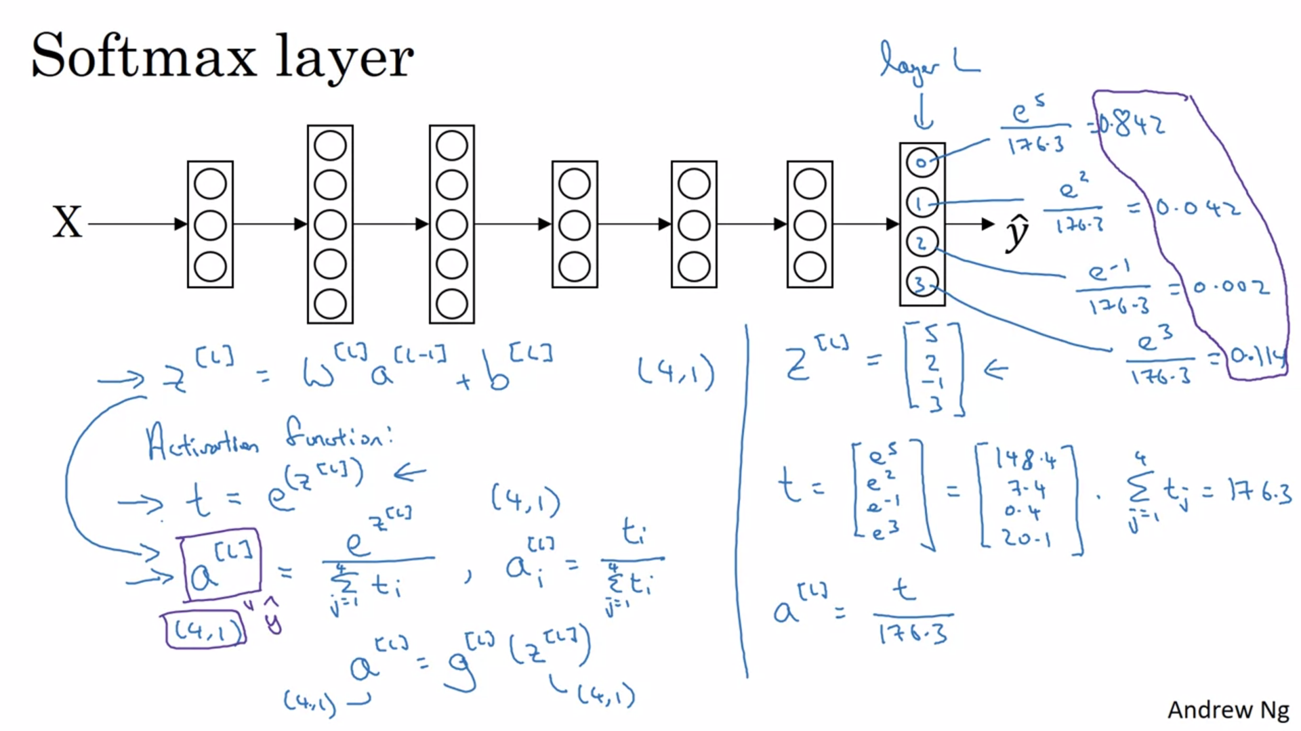

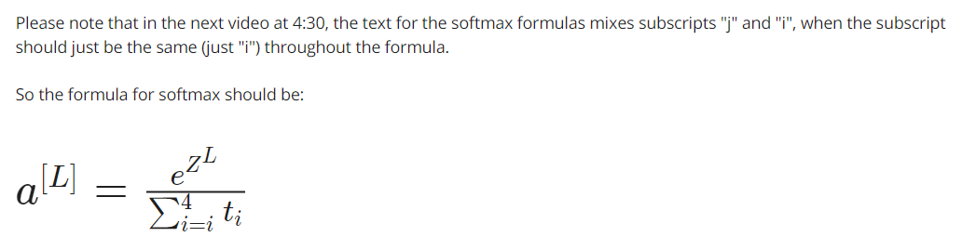

The unusual thing about this particular activation function is that,

this activation function g, it takes a input a 4 by 1 vector and

it outputs a 4 by 1 vector.

So previously, our activation functions used to take in a single row value input.

So for example, the sigmoid and

the value activation functions input the real number and output a real number.

The unusual thing about the Softmax activation function is,

because it needs to normalized across the different possible outputs,

and needs to take a vector and puts in outputs of vector.

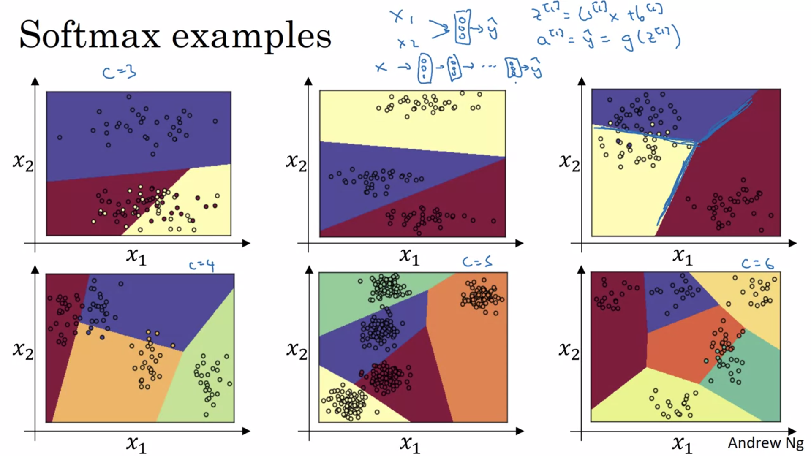

# Training a softmax classifier

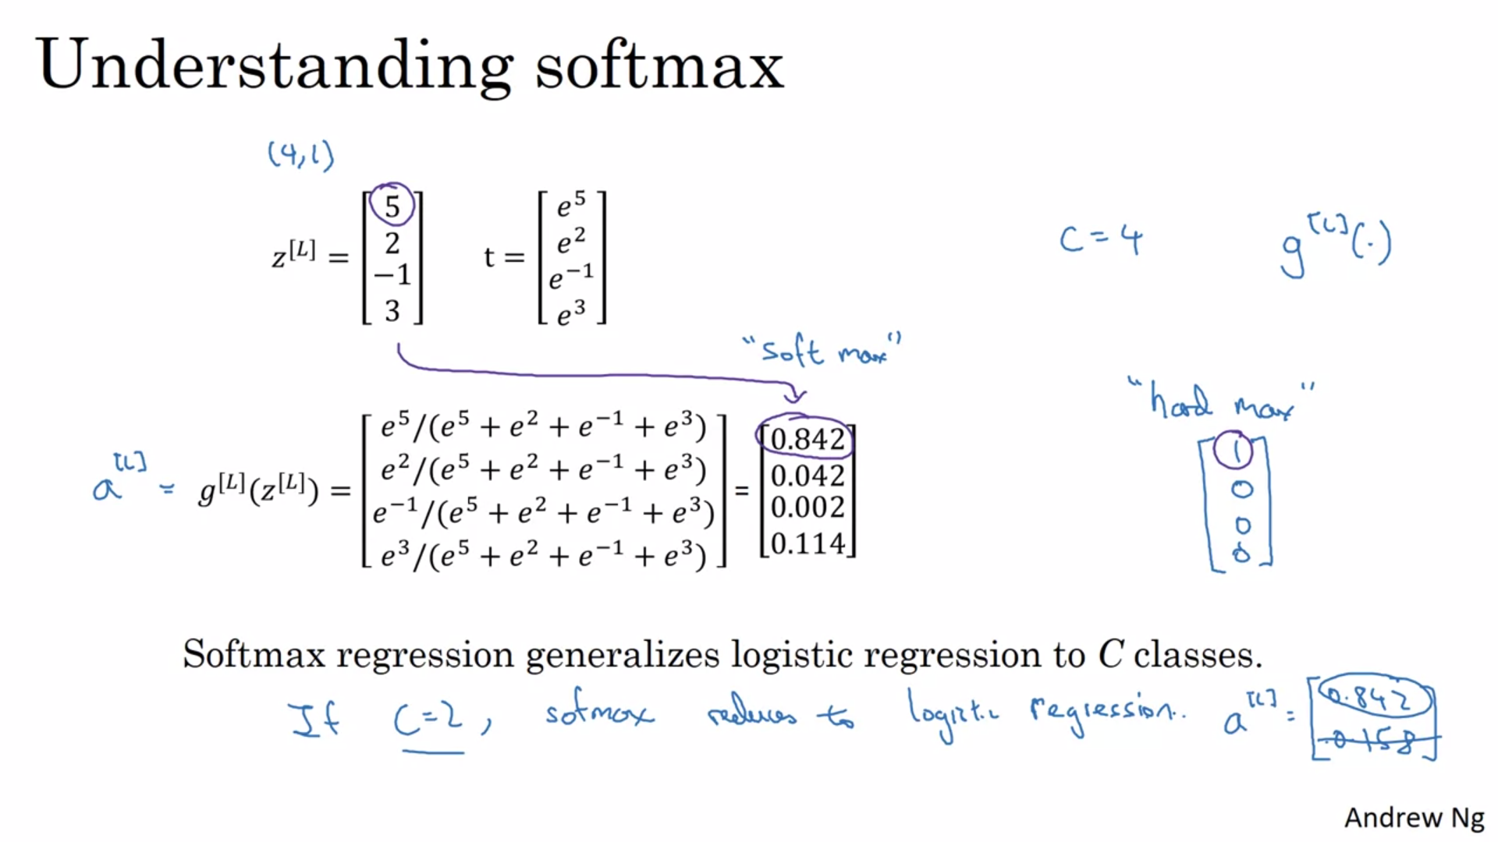

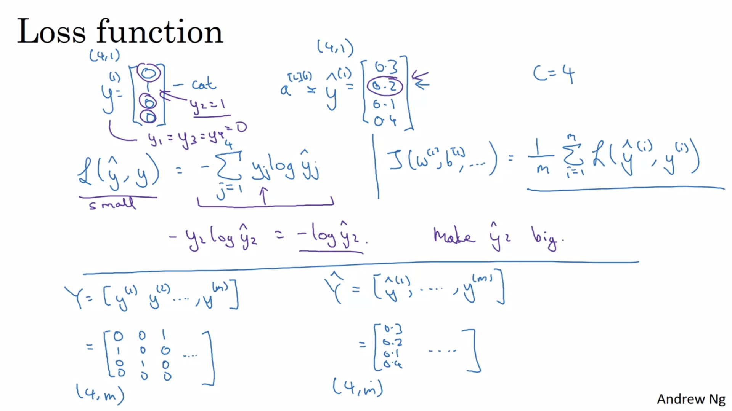

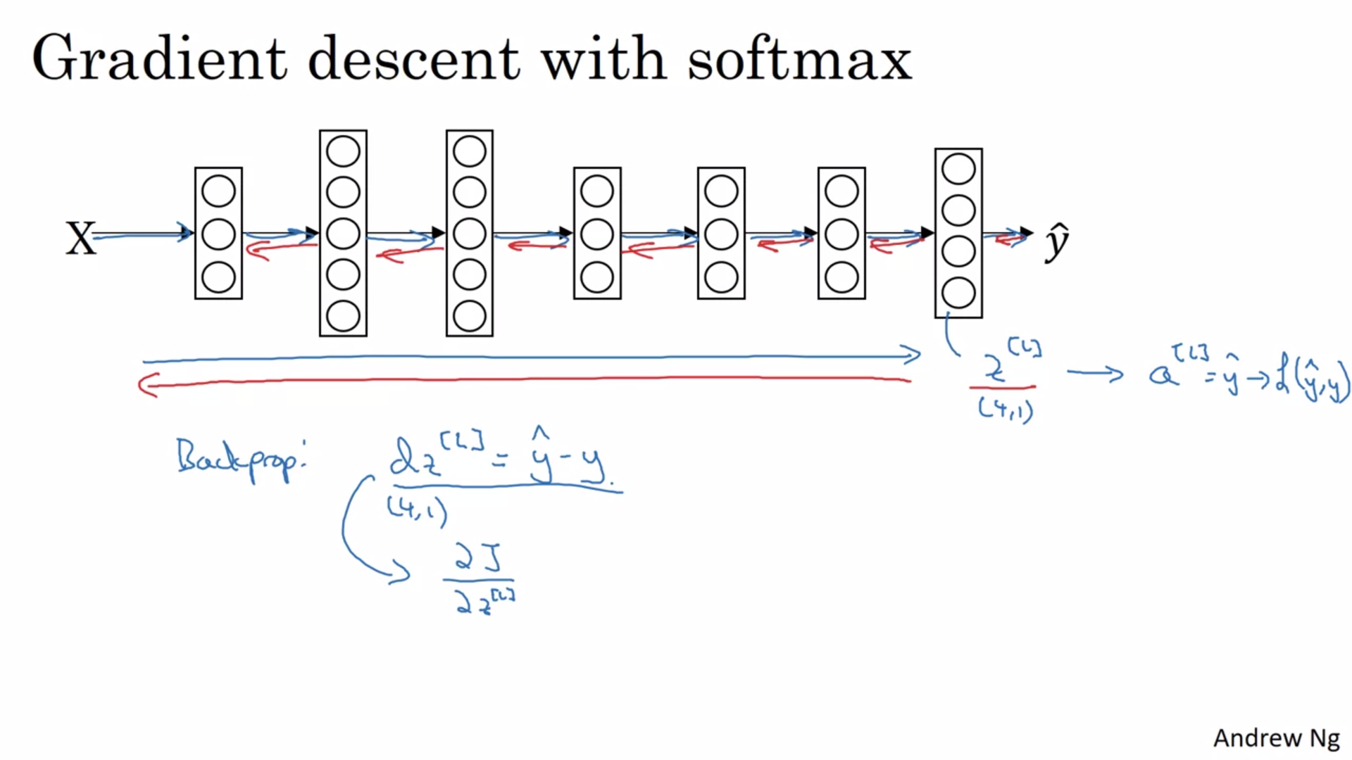

# Deep learning frameworks

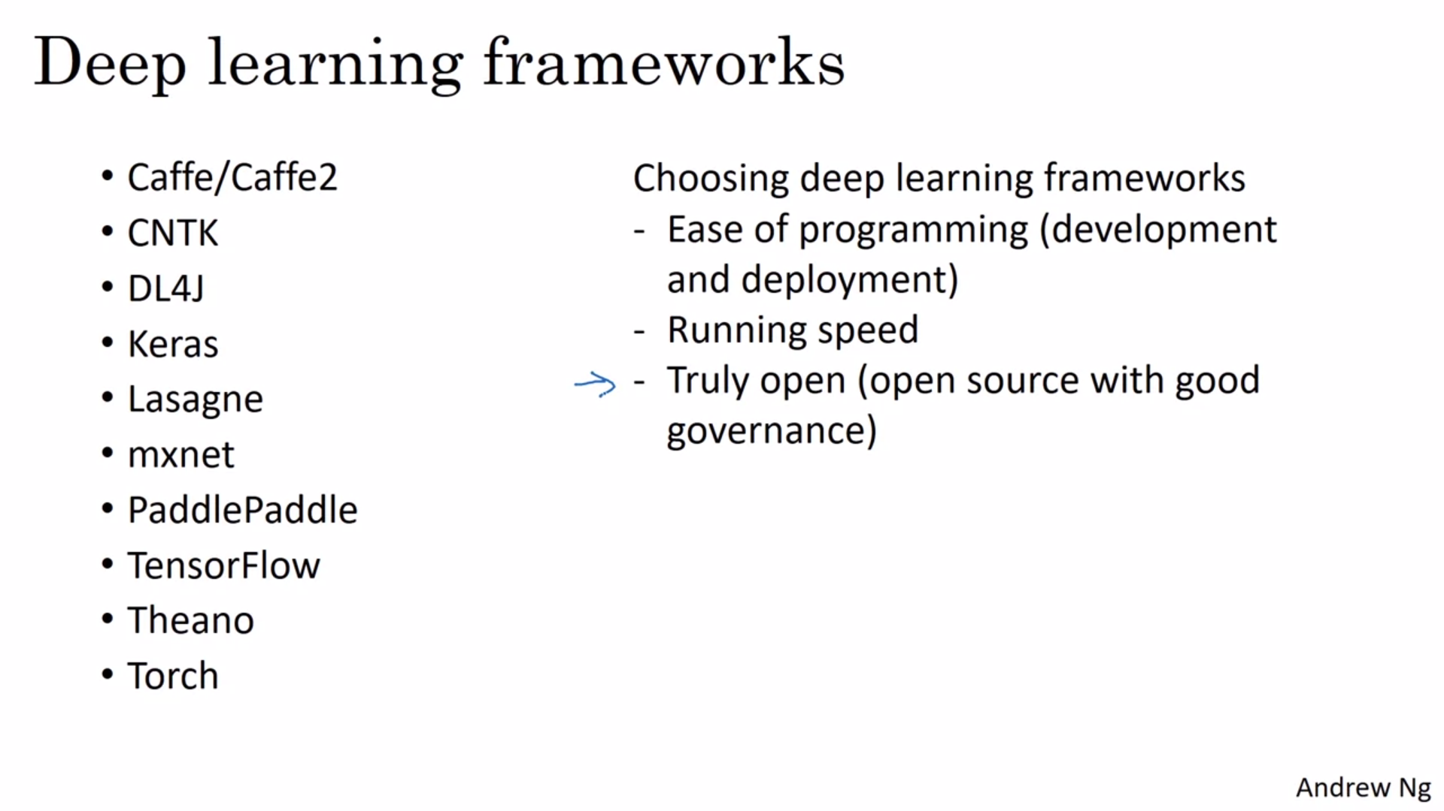

# TensorFlow

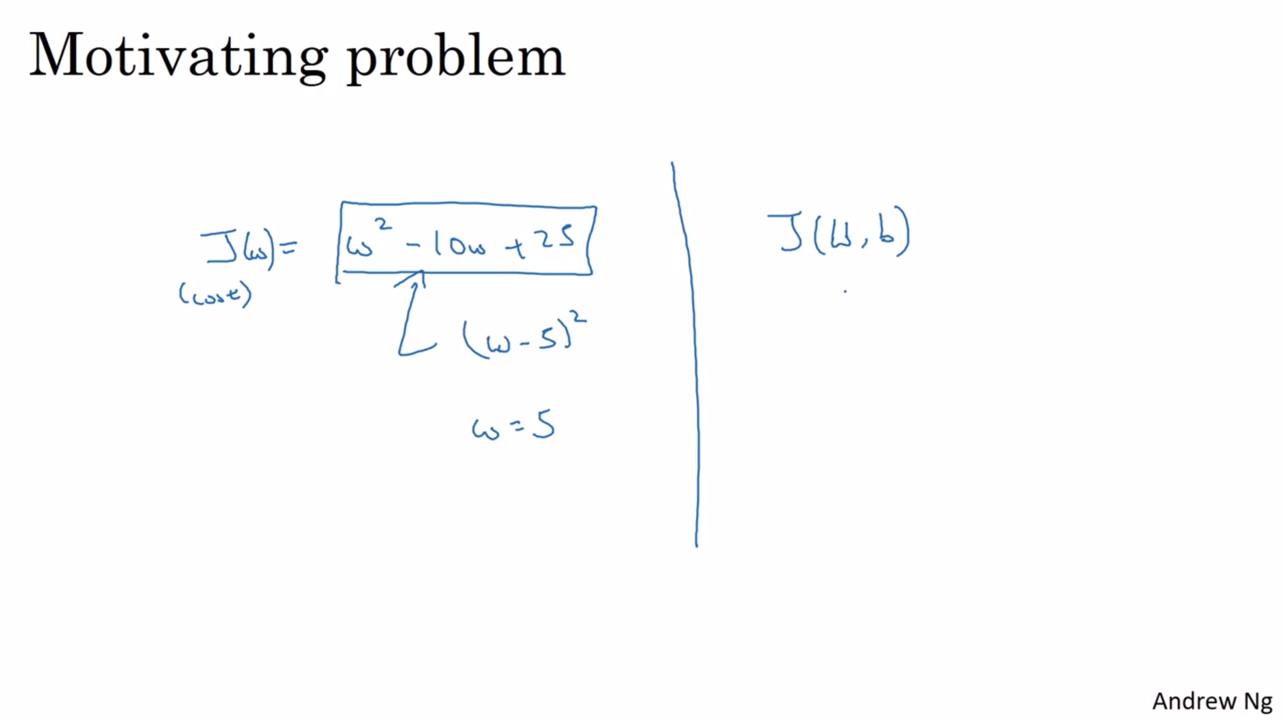

We need to minimize cost function on the left using tensorflow

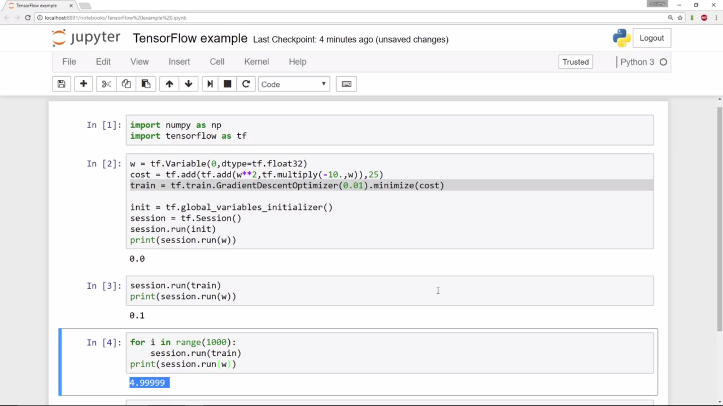

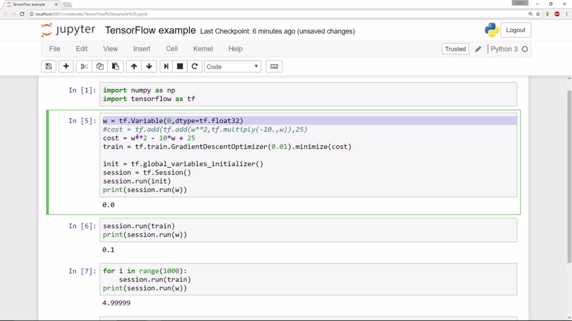

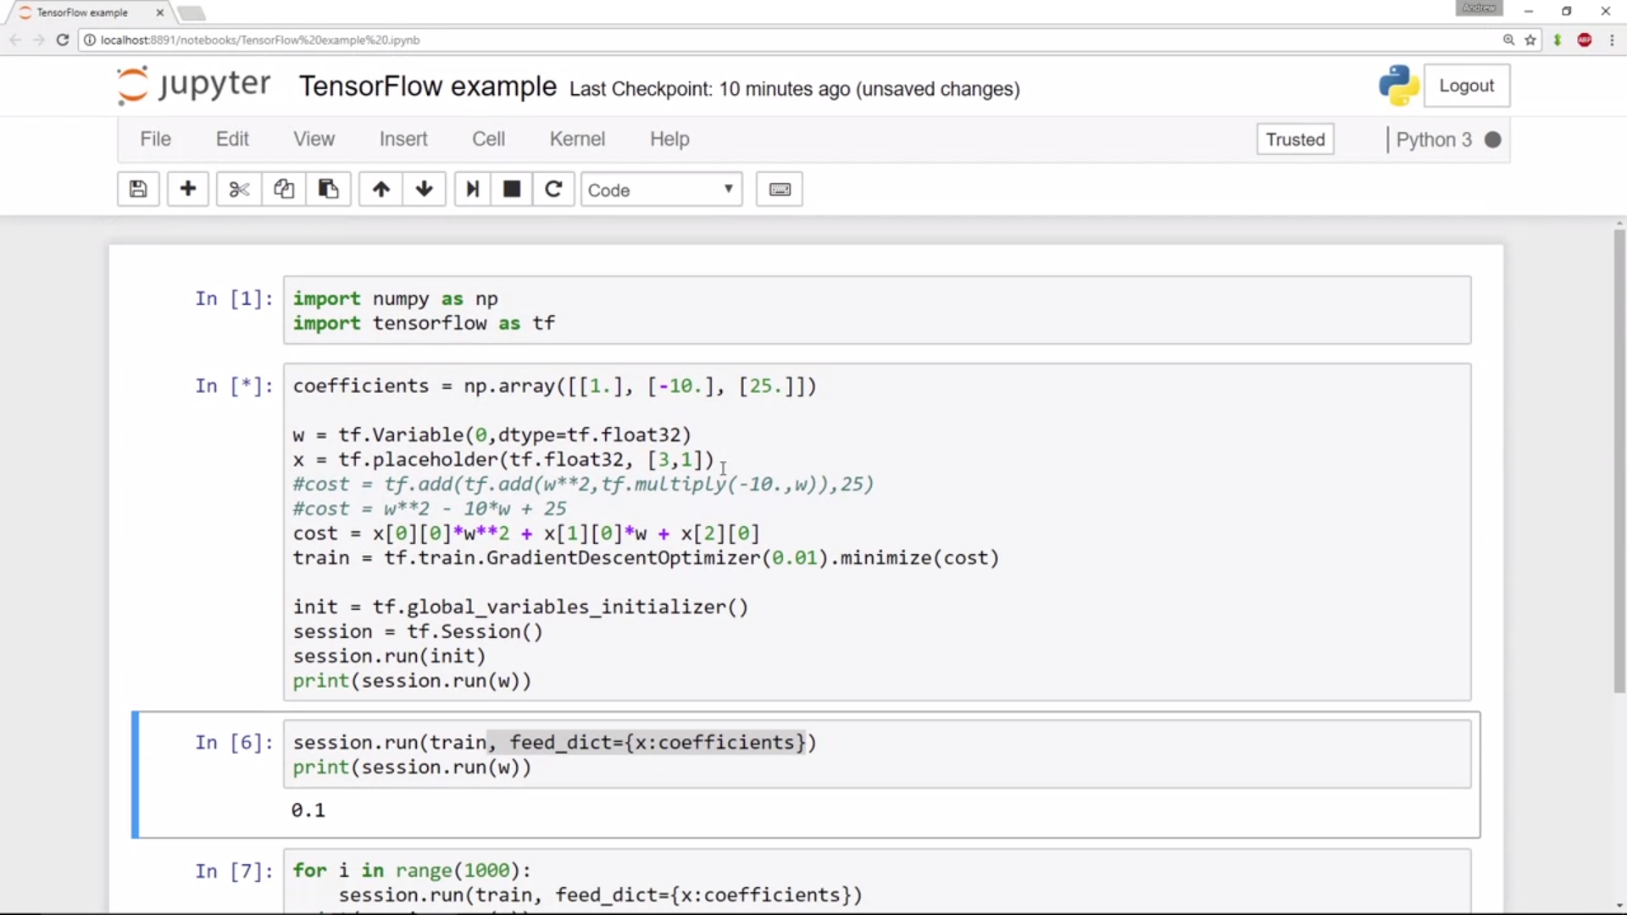

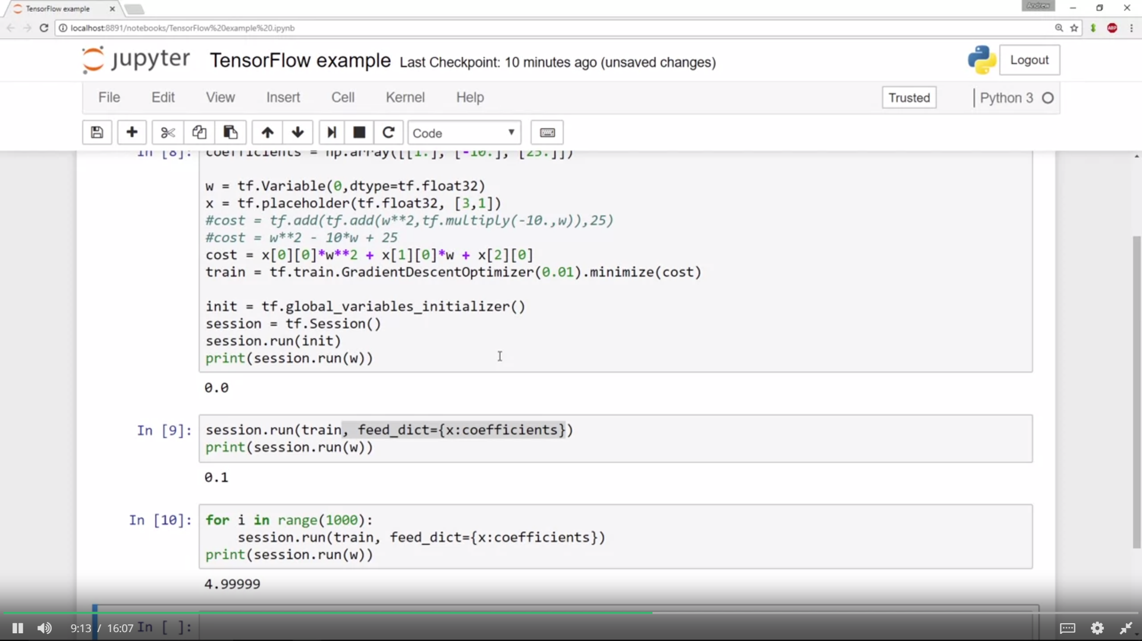

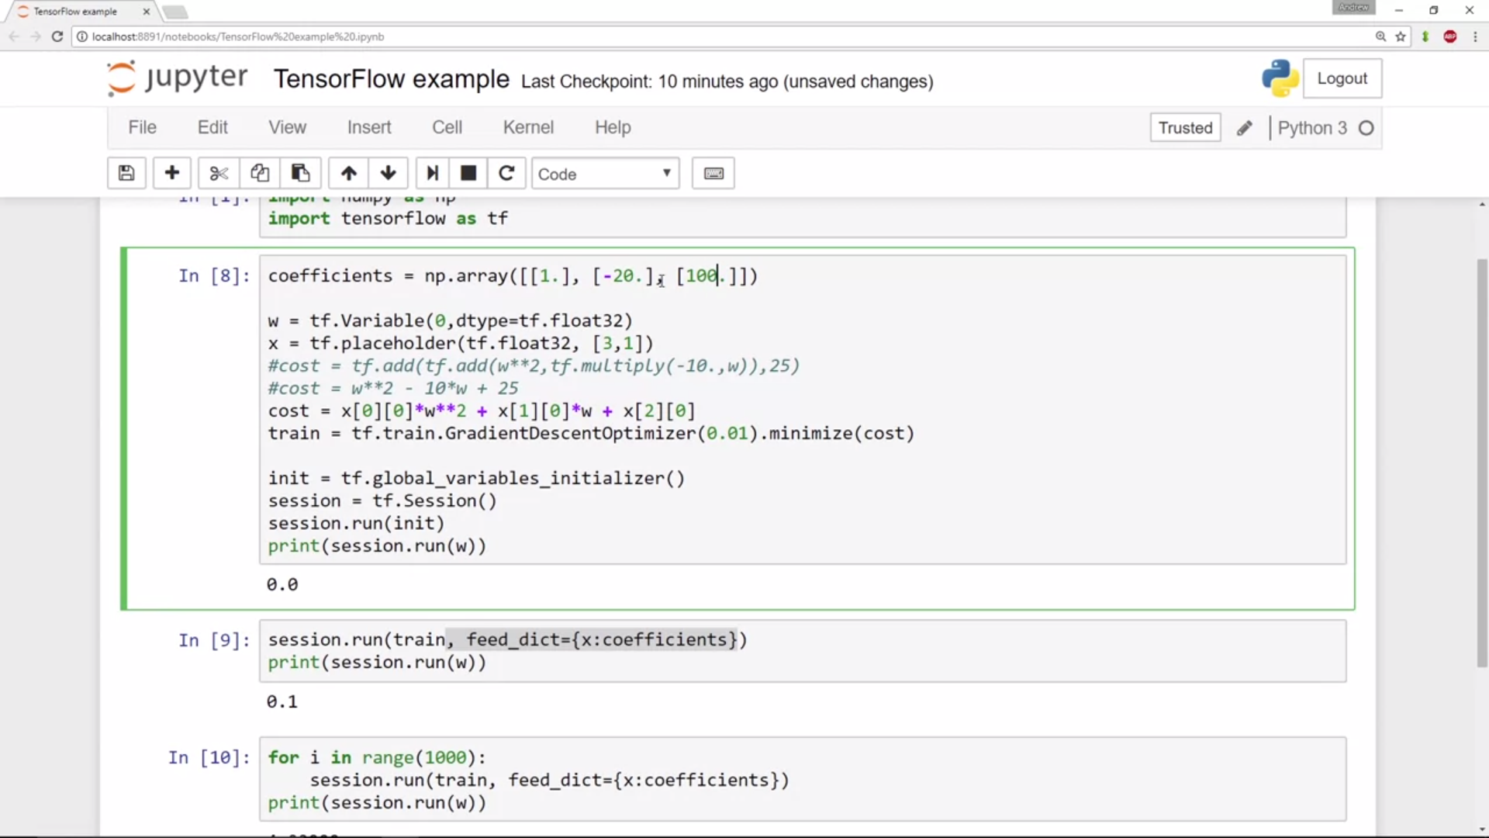

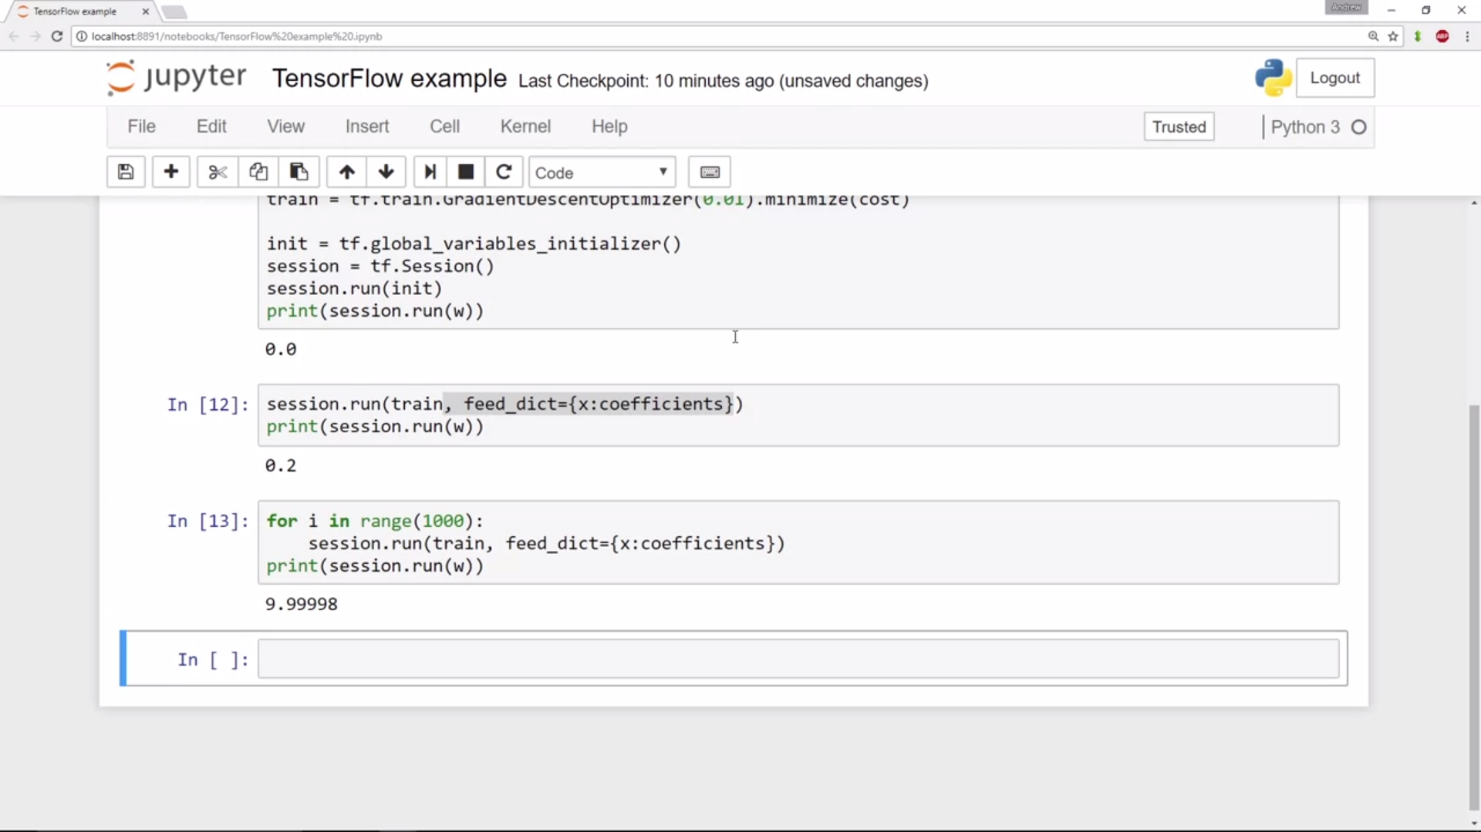

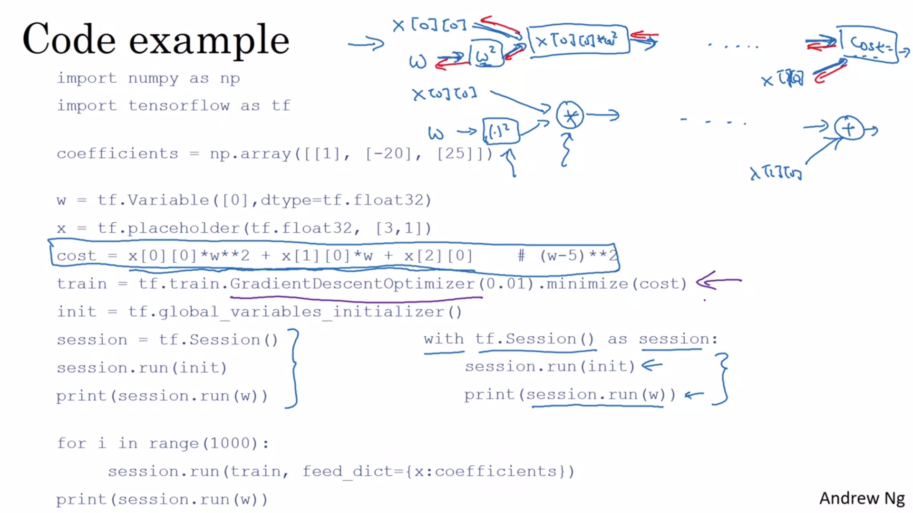

Welcome to this week's programming assignment. Until now, you've always used numpy to build neural networks. Now we will step you through a deep learning framework that will allow you to build neural networks more easily. Machine learning frameworks like TensorFlow, PaddlePaddle, Torch, Caffe, Keras, and many others can speed up your machine learning development significantly. All of these frameworks also have a lot of documentation, which you should feel free to read. In this assignment, you will learn to do the following in TensorFlow:

* Initialize variables
* Start your own session
* Train algorithms
* Implement a Neural Network

Programming frameworks can not only shorten your coding time, but sometimes also perform optimizations that speed up your code.

Writing and running programs in TensorFlow has the following steps:

1. Create Tensors (variables) that are not yet executed/evaluated.
2. Write operations between those Tensors.
3. Initialize your Tensors.
4. Create a Session.
5. Run the Session. This will run the operations you'd written above.

Therefore, when we created a variable for the loss, we simply defined the loss as a function of other quantities, but did not evaluate its value. To evaluate it, we had to run init=tf.global_variables_initializer(). That initialized the loss variable, and in the last line we were finally able to evaluate the value of loss and print its value.

To summarize, **remember to initialize your variables, create a session and run the operations inside the session**.

Next, you'll also have to know about placeholders. A placeholder is an object whose value you can specify only later. To specify values for a placeholder, you can pass in values by using a "feed dictionary" (feed_dict variable). Below, we created a placeholder for x. This allows us to pass in a number later when we run the session.